
Issue
Men’s Health Week –
15th-21st June
Led by the Men's Health Forum to raise awareness of preventable health issues and encourage men and boys to seek professional advice for health-related problems.
It also aims to give all boys and men access to the information services and treatment they need to live healthier, longer and more fulfilling lives.


World Breastfeeding Awareness Week – 1st – 7th August



You and Your GP
WBW is celebrated every 1-7 August in commemoration of the 1990 Innocenti Declaration. WBW started in 1992, with annual themes including healthcare systems, women and work, the International Code of Marketing of Breastmilk Substitutes, community support, ecology, economy, science, education and human rights.

Haslingden Health Care NEWS
The Enhanced Access Service
The Enhanced Access Service in Rossendale is held at Rossendale Primary Healthcare Centre (Inside Ilex View Practice) as well as Irwell Medical Centre (Inside Irwell Medical Practice)
The service is held at Rossendale Primary Healthcare Centre, 17:00pm – 20:45pm on Tuesdays, Wednesdays, Fridays and Saturdays 9-2pm. The service is held at Irwell Medical Centre, 17:00pm – 20:45pm on Mondays and Thursdays. Appointments within this service are both Face to Face and Remote (Telephone/Video Call).
These appointments can be with either a GP, ANP, Practice Nurse or Health Care Assistant. These clinicians have access to your GP Practice record which allows them to see all results, letters and consultations to enable a continuity of care during your appointment with the Enhanced Access Service.
Web: https://eastlancashirealliance.co.uk
Facebook: https://www.facebook.com/EastLancsAlliance/
Email: Ela.servicefeedback@nhs.net

in this issue JUNE 2026 >>>
For up to date information on what you can expect from us as your general practice and how you can help us so that you get the best from the NHS, please refer to our website www.haslingdenmedicalgrouppractice.co.uk
and click the document titled ‘You and your GP’

- Holiday closures
- New staff
- Shingles vaccines
- Summer is here
- Men’s health week
- World Breastfeeding Awareness
- PPG
- Prescription Hub
- Travel vaccinations
- Alcohol awareness week
And MORE…
THE SUMMER ISSUE


Deanne – Practice Nurse

Hello, my name is Deanne and I am your new practice nurse. I have been a qualified nurse for 9 years now, been in GP practices for the last 4 years, I have a real passion for Diabetes and have completes the diabetes pitstop course for oral medications and injectables, competent in insulin and GLP1 starts
I have recently completed the Asthma diploma as well.
I can do Smears, Travel vaccines and immunisations.
bloods, ECGs, long term condition reviews etc.

Ellie – Physician Associate

We’re delighted to share that Ellie, our Physician Associate, has returned from maternity leave and is now available for appointments. Ellie brings her usual compassion, expertise, and dedication to patient care, and we’re thrilled to have her back supporting our community.

NEW STAFF!

Bike Week – 8th-14th June
Encouraging people to get out cycling and switch to cycling as the best way to get around.
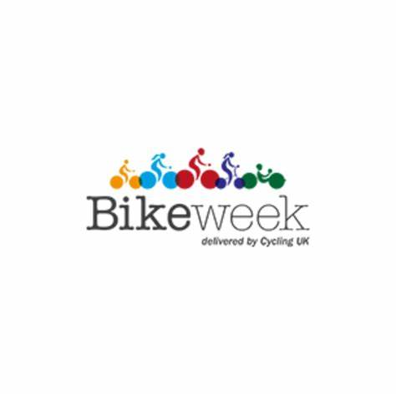
Haslingden Healthcare are now offering a service for all patients to send directly Non-Medical Queries and Admin Requests using the link below, which includes sicknotes, letters and updates regarding test results.
You can access this service using the link below.
https://florey.accurx.com/p/P81099

You can also access this service using the NHS App.

For further information please speak to the reception team.
Patient Non Medical Queries -
A chance for the UK to get thinking about drinking. It’s a week of awareness-raising, campaigning for change, and more. This year the theme is alcohol and work. Discussing the relationship between alcohol and work to help us better understand it and sharing some helpful tips and advice on changes we can make to improve things for us all.
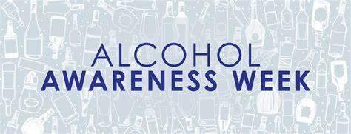
Alcohol Awareness Week – 6th-12th July

Travel Vaccines
We are now offering NHS travel vaccines at the practice. To find out further information and to see if you are eligible, please contact reception and request a travel vaccine questionnaire form.

A questionnaire will be sent across to you to complete and return to us. A nurse will then review this form and an appointment will be made dependent on the review.

Please contact the practice at least 12 weeks in advance before your travel date to start this process
ask the experts >>>
SHINGLES VACCINES
We are offering shingles vaccines to those who are eligible.
Please note that you will receive a text message if you are eligible asking you to book in.
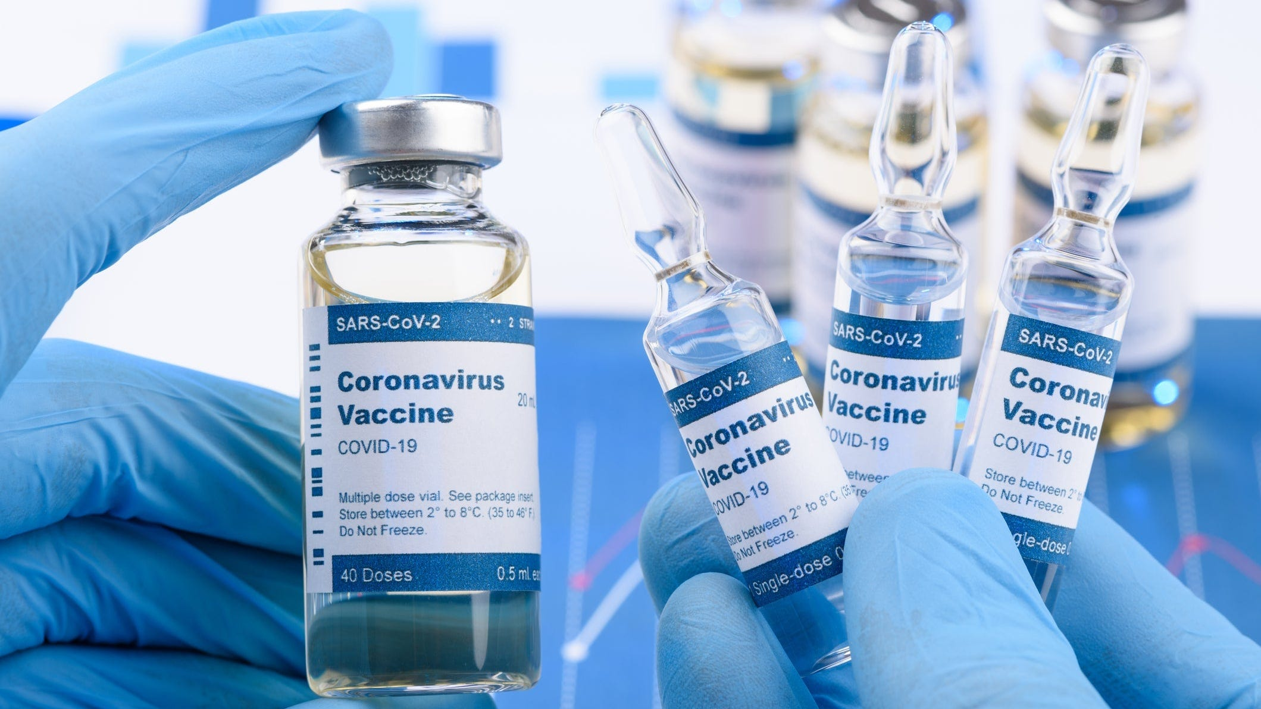
Home Blood Pressure Monitoring Deposits

Our practice has now implemented a new deposit scheme for loaning home blood pressure monitoring machines.

We will now require a £10 deposit before loaning you a machine - this will be returned to you when you bring the machine back to reception.

Please note if you do not bring the home monitoring machine back to reception within 2 weeks this deposit will be non-refundable.

Prebooking appointments through the MyGP App

Please note that we now have limited appointments that are available to book the night before on the MyGP App. These appointments are released at 6.30pm Sunday-Thursday.

Our new prescription hub is now live. If you are over 70 or clinically vulnerable, please contact 01706 335390 and select option 2 to order your prescription.
For anyone that does not meet the above criteria you can either email lscicb-el.macscripts@nhs.net or mackenzie.reception@nhs.net to order. Alternatively, you can order through online patient access or fill in a slip at Reception.

SMOKING CESSATION

Smoking can lead to strokes, cancer, heart and lung disease. We strongly advise quitting. The best way to stop is with a combination of medication and specialist support.

You can try the NHS Quit Smoking app, or for more information visit: www.nhs.uk/smokefree



NEW PRESCRIPTION HUB
It is officially Summer! Light nights and hotter days are upon us

Please make sure to keep your skin protected when the sun is at its hottest by wearing SPF.

The warmer days are here…

Clinical Trials
Stay up to date:
Facebook – Haslingden Healthcare Ltd
Website – www.haslingdenmedicalgrouppractice.co.uk
Email – mackenzie.reception@nhs.net
Number – 01706 335390

HOLIDAY CLOSURE DATES -

Monday 31st August – Summer Bank Holiday
Holiday Closure Dates

Haslingden Healthcare is now participating in clinical trials.
Some patients may be contacted and receive a message alert about these clinical trials requesting you to join in.
If you are interested in the clinical trial then follow the instructions in the message you receive, please do not contact reception about this.
No personal or medical information will be released without your consent.

Would you like to join our PATIENT PARTICIPATION GROUP?
We are looking for enthusiastic, dedicated patients for their views on upcoming changes and to help shape the delivery of services. Some questions that could be raised are below…

- How long do I have to wait for a GP appointment?
- How can I access mental health services?
- I just want to check my blood test results, can I do this without speaking to a healthcare professional?
- Why do the receptionists need to know what my appointment is for?

For more information please contact reception:
01706 335590 or mackenzie.reception@nhs.net

Finding An Agent That’s Right For You

