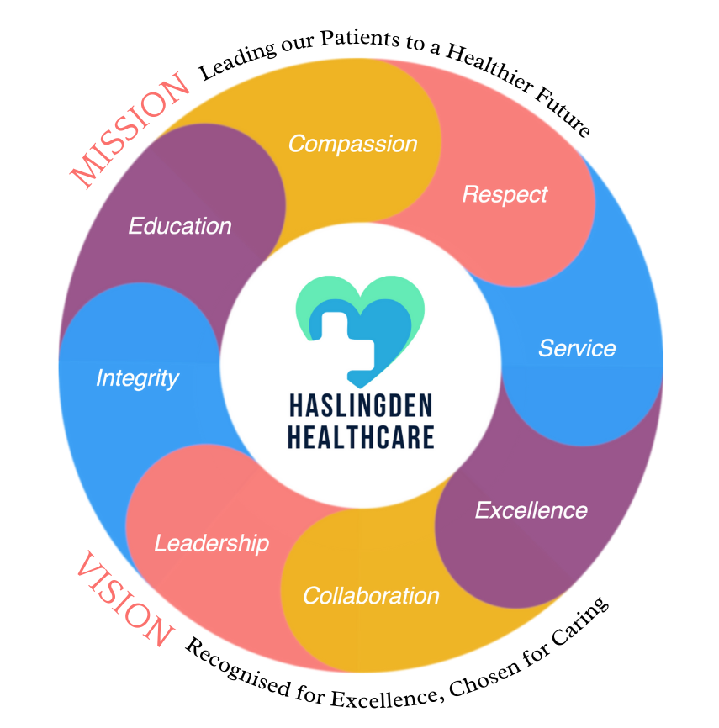

***in this issue MARCH 2024 >>>***

Issue



Ramadan 2024 is expected to begin on Monday 11th March and end around Tuesday April 9th, depending on the sighting of the moon.

Eid al-Fitr, which marks the end of Ramadan is expected to be celebrated around April 10th.

**We would like to wish our fellow Muslim community a happy Eid!**

**Purple Day for Epilepsy – 26th March 2024**

[Purple Day is an**international effort dedicated to increasing awareness about epilepsy worldwide**](https://www.bing.com/ck/a?!&&p=c6392f0ae3c468f4JmltdHM9MTcwOTUxMDQwMCZpZ3VpZD0xOWZhZjI5Yy0xN2VkLTYzMzUtM2VjOS1lNmI5MTZkZDYyMzcmaW5zaWQ9NTg2Mg&ptn=3&ver=2&hsh=3&fclid=19faf29c-17ed-6335-3ec9-e6b916dd6237&psq=purple+day+for+epilepsy&u=a1aHR0cHM6Ly93d3cucHVycGxlZGF5Lm9yZy8&ntb=1)**!**

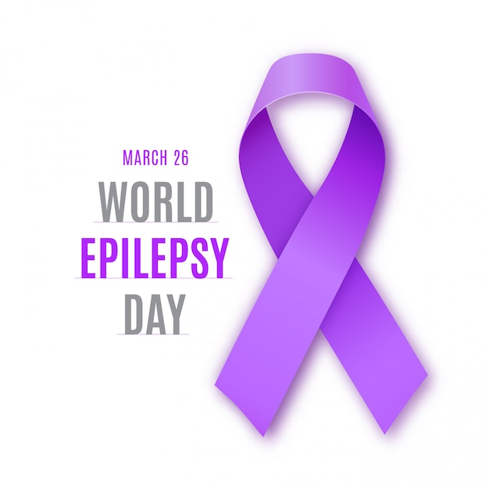

World Parkinson’s Day is an opportunity to support the community, to raise their voices, to share their experiences of living with Parkinson’s and to use our resources to back and amplify their ideas 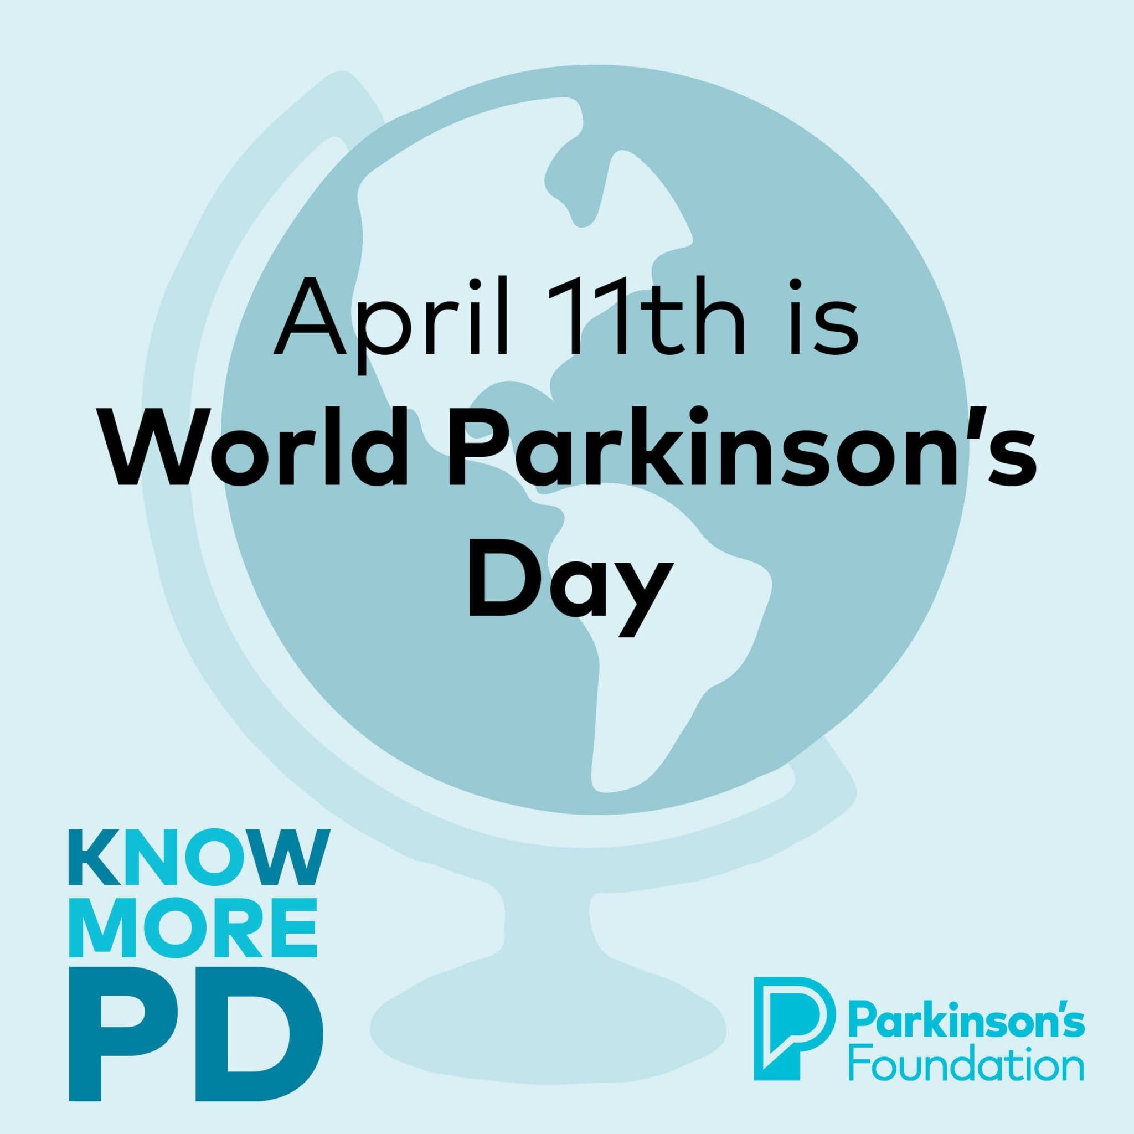

***Parkinsons Disease International Awareness Day – April 11th***

* *Parkinsons Awareness day*
* *Ramadan 2024*
* *Covid Spring Booster*
* *National Epilepsy Day*
* *Easter 2024*
* *Bank Holiday Closures*
* *World Ovarian cancer day*

***Ramadan 2024***

* *GetUBetter MSK app*
* *Clinical Trials*
* *PPG*

And MORE…

The Enhanced Access Service

The Enhanced Access Service in Rossendale is held at Rossendale Health Centre (Inside Ilex View Practice) as well as Bacup Health Centre (Inside Irwell Medical Practice)

The service is held at Rossendale Health Centre, 17:00pm – 20:45pm on Tuesdays, Wednesdays, Fridays and Saturdays 9-2pm. The service is held at Bacup Health Centre, 17:00pm – 20:45pm on Mondays and Thursdays. Appointments within this service are both Face to Face and Remote (Telephone/Video Call).

These appointments can be with either a GP, ANP, Practice Nurse or Health Care Assistant. These clinicians have access to your GP Practice record, to enable them to see all results, letters and consultations to enable a continuity of care during your appointment with the Enhanced Access Service.

Web: [**https://eastlancashirealliance.co.uk**](https://eastlancashirealliance.co.uk/)

Facebook: [**https://www.facebook.com/EastLancsAlliance/**](https://www.facebook.com/EastLancsAlliance/)

Email: [**Ela.servicefeedback@nhs.net**](mailto:Ela.servicefeedback@nhs.net)

**Haslingden Health Care NEWS**

**THE SPRING ISSUE**



**Dr James Barsby**

Hello, My Name is James Barsby, I am a new staff member at Haslingden Health Care. I am currently a GPST2 with the practice and I am here until August. I graduated from Manchester Medical school in 2019. I have a current interest in paediatrics. I see all patients face to face and also carry out telephone consultations.

**Zacharias Akram**

Hello, my name is Zacharias. I am an in-house physiotherapist that works as a apart of the PCN. I am here in practice every Friday; you can book in for a telephone appointment with me in my morning clinic or book in to see me face to face in my afternoon clinic. I deal with any physical problems caused by an injury, illness, disability or aging. I assess, diagnose, and treat the issue by using methods such as exercise, manual therapy, education and advice.

**Nurse Vanessa O’Brien**

Our lovely practice nurse Vanessa is retiring after 39 years. She has been an integral part of our team since 1985.

She has seen many patients and different doctors come and go. She would like to say what a pleasure it has been looking after all the patients of Haslingden and wishes everyone the best! Her last working day in practice is the 26th April 2024. We wish you all the very best for the future Vanessa and good luck in your retirement :)

*Staff News!*



World Ovarian Cancer Day – May 8th

Established in 2013 by a group of leaders from ovarian cancer advocacy organizations around the world.

May 8 – World Ovarian Cancer Day is the one day of the year we globally raise our voices in solidarity in the fight against ovarian cancer.



Haslingden Healthcare are now offering a service for all patients to send directly Non-Medical Queries and Admin Requests using the link below, which includes sicknotes, letters and updates regarding test results.

You can access this service using the link below.

[**https://florey.accurx.com/p/P81099**](https://florey.accurx.com/p/P81099)

**You can also access this service using the NHS App.**

**For further information please speak to the reception team.**

*Patient Non Medical Queries -*

***ask the experts >>>***

SMOKING CESSATION

Smoking can lead to strokes, cancer, heart and lung disease. We strongly advise quitting. The best way to stop is with a combination of medication and specialist support.

*You can try the NHS Quit Smoking app, or for more information visit:* [*www.nhs.uk/smokefree*](http://www.nhs.uk/smokefree)



The practice will be closed on the following dates:

Good Friday – Friday 29th March

Easter Monday – Monday 1st April

Early May Bank Holiday – Monday 6th May

Spring Bank Holiday – Monday 27th May

For urgent requests please contact NHS 111. In an emergency dial 999.

We would like to wish a Happy Easter to all our patients!



*Bank Holiday Closures…*

COVID VACCINES

We are now offering appointments for the Spring Covid Booster.

Please contact reception to get booked in.

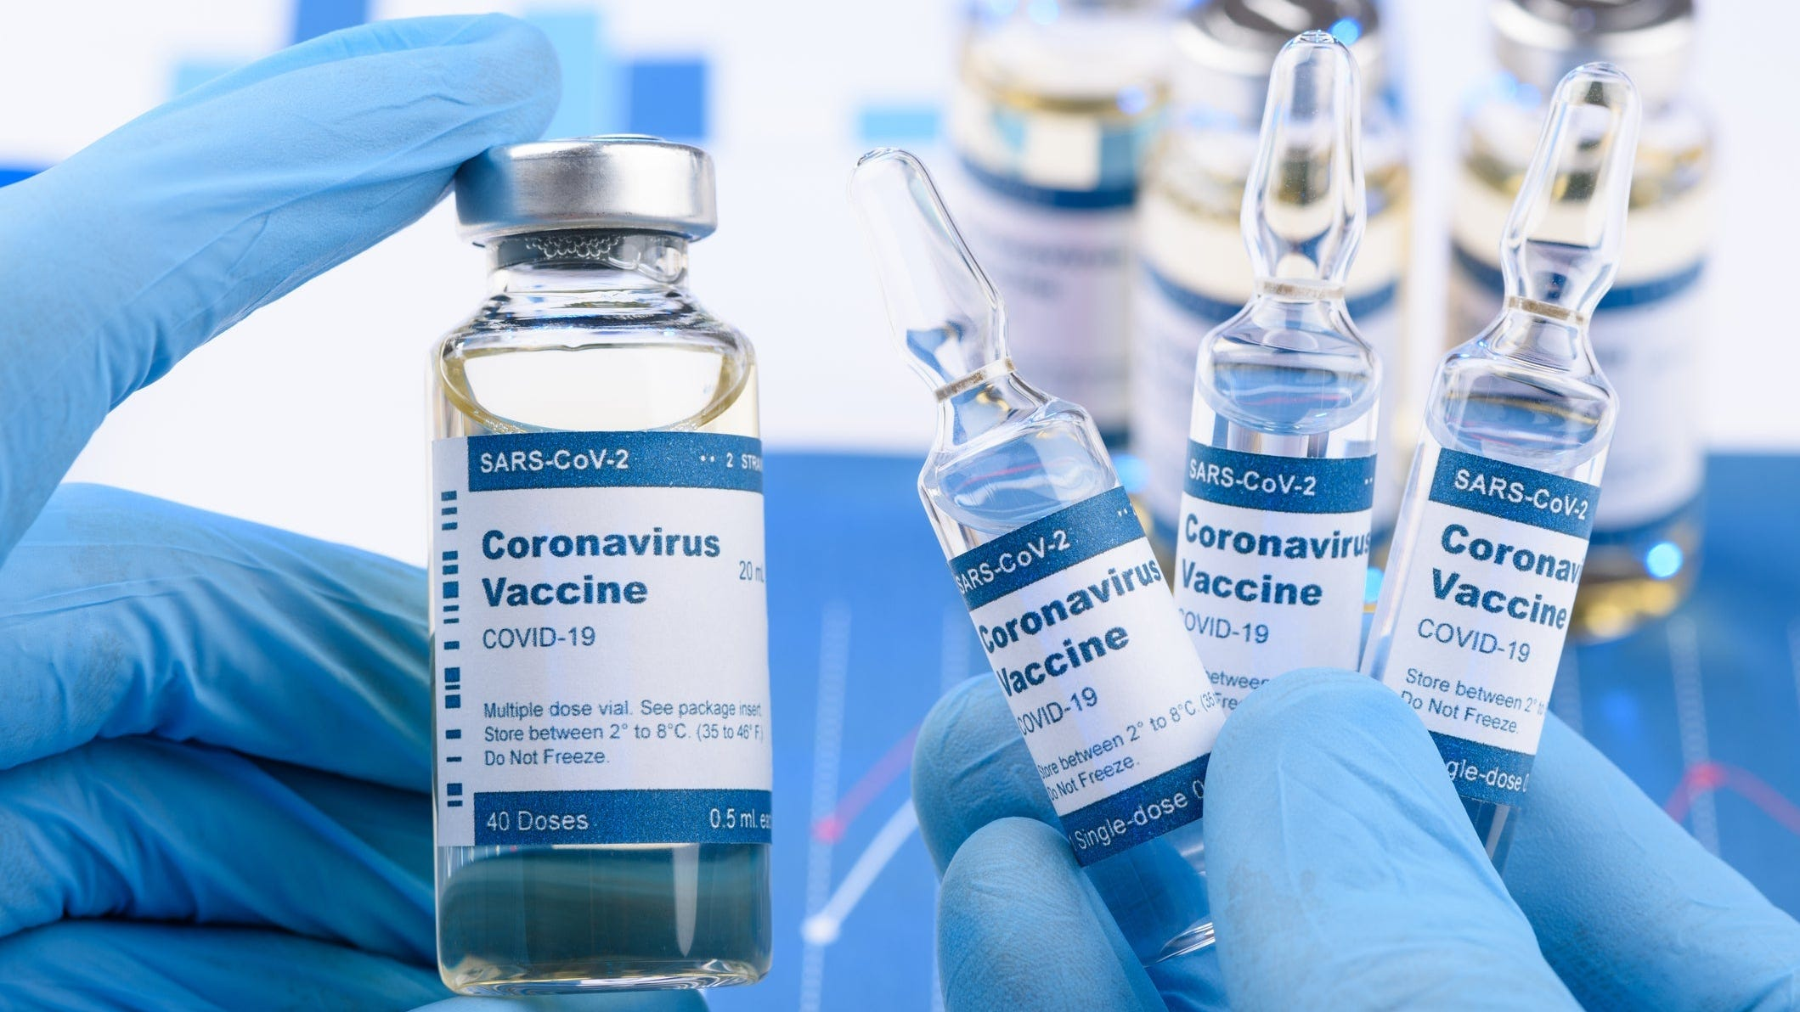

*GetUBetter MSK App*

Do you have a joint or muscle problem?

Please use the FREE NHS GetUBetter app designed and written by your local clinicians here in East Lancashire.

It offers local tips, advice and exercises tailored to you and your stage of recovery.

* Instant access
* Easy to use
* Safe and effective

Your healthcare professionals cannot be with you 24/7, but GetUBetter can…

Download the app here -   [**https://app.getubetter.com/request-access/1/571d3a9420bfd9219f65b643d0003bf4**](https://app.getubetter.com/request-access/1/571d3a9420bfd9219f65b643d0003bf4)

It is officially Spring! Lighter nights and warmer days are upon us.

Hayfever season is now here. Airborne grass pollens are at their peak in Spring, please make sure to stay protected.

***The warmer days are coming…***

Haslingden Healthcare is now participating in clinical trials.

Some patients may be contacted and receive a message alert about these clinical trials requesting you to join in.

If you are interested in the clinical trial then follow the instructions in the message you receive, please do not contact reception about this.

**No personal or medical information will be released without your consent.**





Clinical Trials

Prescriptions

Just a gentle reminder to patients that our prescription phone line is open from 9.00am-12.00pm.

Alternatively, you can order prescriptions through the NHS app, email or pop into reception.

**Stay up to date:**

Facebook – Haslingden Healthcare Ltd

Email – [mackenzie.reception@nhs.net](mailto:mackenzie.reception@nhs.net)

Number – 01706 335390

Would you like to join our PATIENT PARTICIPATION GROUP?

We are looking for enthusiastic, dedicated patients for their views on upcoming changes and to help shape the delivery of services. Some questions that could be raised are below…

* How long do I have to wait for a GP appointment?
* How can I access mental health services?
* I just want to check my blood test results, can I do this without speaking to a healthcare professional?
* Why do the receptionists need to know what my appointment is for?

For more information please contact reception:

01706 335590 or mackenzie.reception@nhs.net

*Finding An Agent That’s Right For You*