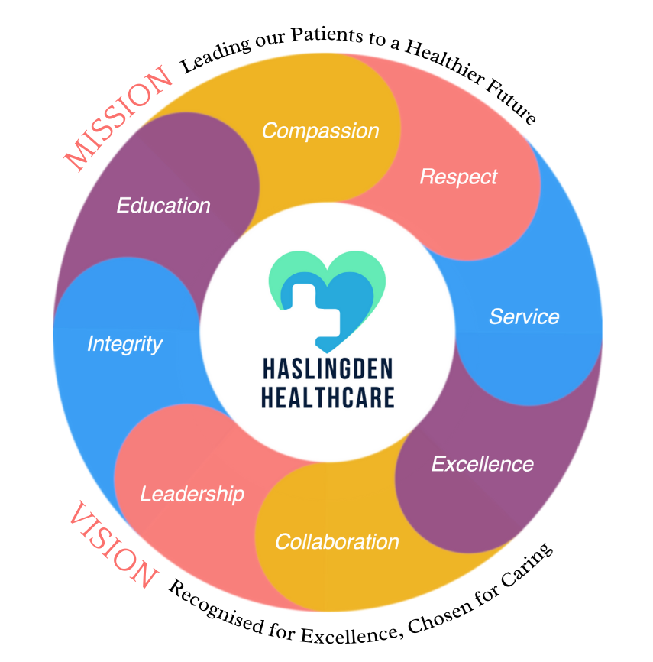

***In this issue JUNE 2023 >>>***

Issue

* *Covid pass scams*
* *Care Packs*
* *Online access info*
* *Prescriptions*

And MORE…

* *Extra services we offer*
* *The Enhanced Access Service*
* *75 Years of the NHS*
* *Patient non medical queries*
* *Patient Participant group*
* *Welcome new staff*
* *NHS covid pass*

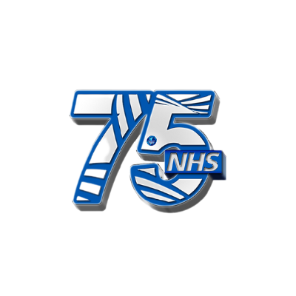

On the 5th July 2023 the NHS will mark 75 years of service to the UK.

Treating over a million people a day in England, the NHS touches all of our lives. When it was founded in 1948, the NHS was the first universal health system to be available to all, free at the point of delivery. Today, nine in 10 people agree that healthcare should be free of charge, more than four in five agree that care should be available to everyone, and that the NHS makes them most proud to be British.

***NHS 75th Birthday!***

The Enhanced Access Service

We currently offer exra services within our practice, these include;

* In house physiotherapist
* Health and well being coach
* Primary mental health workers for children and adults
* Clinical pharmacists

The Enhanced Access Service in Rossendale is held at Rossendale Health Centre (Inside Ilex View Practice) as well as Bacup Health Centre (Inside Irwell Medical Practice)

The service is held from Rossendale Health Centre, 17:00pm – 20:45pm on Tuesdays, Wednesdays, Fridays and Saturdays. The service is held from Bacup Health Centre, 17:00pm – 20:45pm on Mondays and Thursdays. Appointments within this service are both Face to Face and Remote (Telephone/Video Call).

These appointments can be with either: GP ANP Practice Nurse Health Care Assistant These clinicians have access to your GP Practice record, to enable them to see all results, letters and consultations to enable a continuity of care during your appointment with the Enhanced Access Service

Web: [**https://eastlancashirealliance.co.uk**](https://eastlancashirealliance.co.uk/)

Facebook: [**https://www.facebook.com/EastLancsAlliance/**](https://www.facebook.com/EastLancsAlliance/)

Email: [**Ela.servicefeedback@nhs.net**](mailto:Ela.servicefeedback@nhs.net)

**Haslingden Health Care NEWS**



**THE SUMMER ISSUE**

*Extra services we offer…*



Hello, my name is Laraeb.I am a First Contact Physiotherapist.

My role is to help patients with musculoskeletal issues such as back, neck and joint pain by:-Assessing and diagnosing issues

-Giving expert advice on how best to manage their conditions.

-Referring them onto specialist services if necessary.

Making it easier for patients to access skilled MSK practitioners, patients will have quicker access to diagnosis and treatment, helping them to manage their conditions more effectively and recover faster, so they can get back to normal life quickly. This will also help to reduce GP workload and allow them to focus on patients that need them most.

Hello, my name is Humaira. I am an Associate Psychological Practioner (APP) . I provide mental health prevention and promotion service which offers patients upto 4 sessions aimed at managing low to moderate levels of mental health related conditions. The inclusion criteria is included below.

Anyone who would benefit from mental health promotional or preventative advice delivered within the context of a brief intervention e.g., patients presenting with stress, reduced well-being and/or common mental health symptoms such as depression or anxiety.

People who need extra support with their mental health; low mood, anxiety, stress etc

People whose physical health conditions are impacting on their mental wellbeing

People who are struggling with circumstances relating to COVID-19

Anyone who would benefit from basic psychological advice regarding: Sleep hygiene, Healthy lifestyle

, Relaxation/breathing techniques, Stress/worry management, Low mood management

Hello, my name is Ruth I am the Mental Health Practitioner at Haslingden Medical Practice. I have been a qualified Mental Health Nurse for 15 years. I have wide range of experience working in mental health care, on the mental health inpatient units, in urgent care and in the community. My role in primary care is to provide specialist advice and support with all mental health needs and signpost to relevant practitioners for ongoing support.I will see anyone aged 16 and above and can offer face to face or telephone consultations for up to 30 minutes.I am at Haslingden every Wednesday, there is no need to get a referral via GP just book in with me directly through reception.

*Welcome the new clinical staff!*



We are currently offering care packs filled with information to help you understand more about your diagnosis if you have been recently diagnosed with either cancer or dementia.

These care packs include leaflets and guides to help support you and your loved ones.

Please contact reception if you have not yet picked yours up.

Haslingden Healthcare are now offering a service for all patients to send directly Non-Medical Queries and Admin Requests using the link below, which includes sicknotes, letters and updates regarding test results.

You can access this service using the link below.

[**https://florey.accurx.com/p/P81099**](https://florey.accurx.com/p/P81099)

**You can also access this service using the NHS App.**

**For further information please speak to the reception tem.**

**Care Packs**

*Patient Non Medical Queries -*

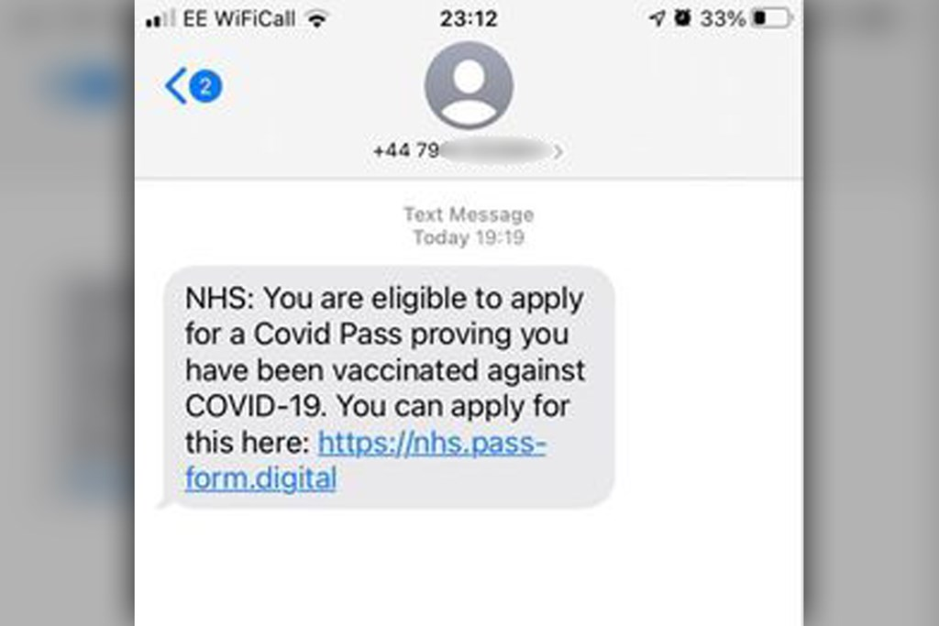

*NHS COVID PASS*

***ask the experts >>>***

Option congue nihil imperdiet doming id quod mazim placerat facer minim veni am ut wisi enim ad minimeniam, quis erat nostr uexerci tation ullamcorper nostru exerci tation ullam corper et iusto odio dig nissim qui blandit praesent lupta. Tummer delenit augue duis dolore magna erat aliquam erat volutpat. Nam liber tempor cum soluta nobis sed.

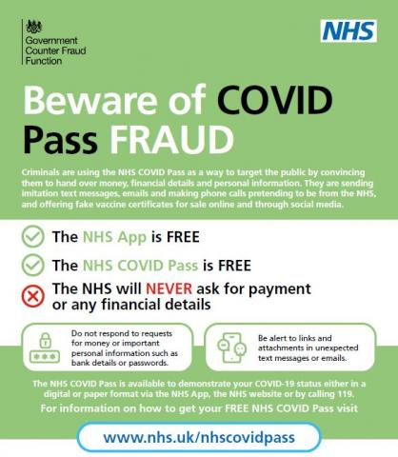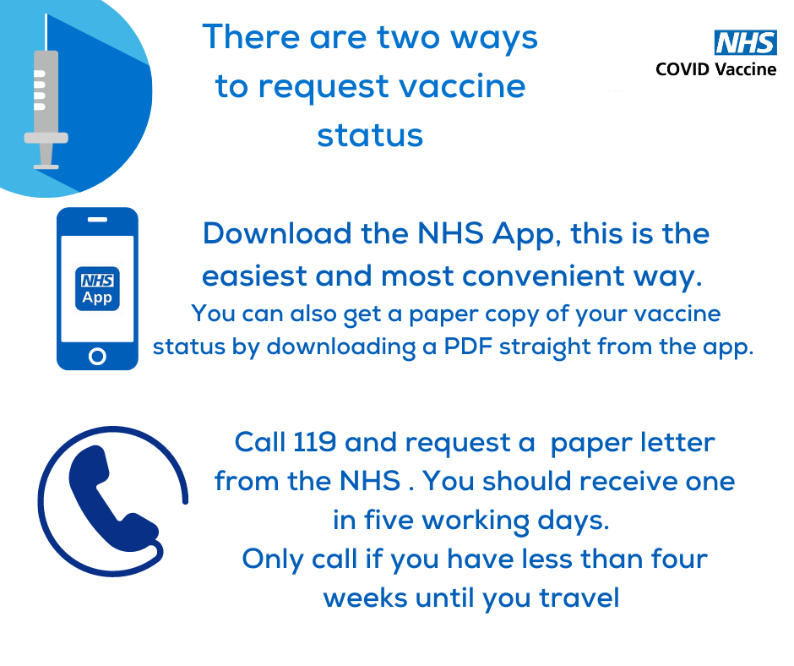

An NHS COVID-19 pass is now available to anyone aged 12 and over.

Children aged 12 can now access a COVID-19 pass on the NHS app without requesting online services from the surgery.

The NHS website have a page dedicated to retrieving a digital COVID-19 pass.

If you experience any issues with the NHS app, please call 119 to discuss them.

QUICK NOTE: Please use the NHS website to create your NHS account, NOT THE APP. Once you have created your account, you will receive a security code which you can then use to log into the NHS app.

There has recently been reports of COVID-19 pass scam messages across the UK (see above).

Please remember that any message orginating from the NHS will not come through as a +44 mobile number.

The text will be from “NHS” or “NHS England”.

If you receive a message like this, DO NOT click on any links.

BLOCK the number and DELETE the message.

COVID-19 PASS SCAMS

Online Access

Prescriptions

Just a gentle reminder to patients that our prescription phone line is open from 9.00am-12.00pm.

Alternatively, you can order prescriptions through the NHS app, email or pop into reception.

**Stay up to date:**

Facebook – Haslingden Healthcare Ltd

Email – [mackenzie.reception@nhs.net](mailto:mackenzie.reception@nhs.net)

Number – 01706 335390





Would you like to join our PATIENT PARTICIPATION GROUP?

We are looking for enthusiastic, dedicated patients for their views on upcoming changes and to help shape the delivery of services. Some questions that could be raised are below…

* How long do I have to wait for a GP appointment?
* How can Iccess mental health services?
* I just want to check my blood test results, can I do this without speaking to a healthcare professional?
* Why do the receptionists need to know what my appointment is for?

For more information please contact reception:

01706 335590 or mackenzie.reception@nhs.net

By 31st October 2023, all GP practices will let you see new entries in your GP health record online and through the NHS app, including appointment notes, letters and test results.

It is officially summer! Lighter evenings and hot weather is on the way.

Please make sure to wear SPF sunscreen and stay hydrated…

*Hotter days are coming*

*Finding An Agent That’s Right For You*